
Empowering Knowledge & Excellence-Inspiring Values & Patriotism
BHONDAWE PATIL PUBLIC SCHOOL

SET - 1

Student’s Name:- ……………………………………………… Roll No:
Subject: - Science Grade: IV Div.
Time:- 2 Hours Date :
Obtain Mark
Invigilator’s Sign Total Mark 20 Evaluator’s Sign

SECTION A
Q.1) Fill in the blanks with correct options. [2M]
1]_____________ is the beautiful part of plant. [Root/ Flower]
2] Roots grow ___________________ ground.[above/ under]
3] Herbs are _________________ plants. [small /big]
4] Plants grow along the ground are _____________. [creepers/ climbers]

Q.2) Circle the odd one out in each of the following. [2M]
1] Rose, Lotus, Mango
2] Coriander, Cactus, Spinach
3] Water Lily, Lotus, Pitcher
4] Mango, Neem,Coconut
Q.3 Classify the things. [2M]
Water Lily, Duckweed, Tape Grass, Pitcher

1.Floating Plant: - ______________________________________
2.Fixed Plant: - ____________________________________
3.Under Water Plant:- __________________________________
4.Carnivorous Plant : - ____________________________________
Q.4) Tick the odd one out. [2M]
1]Which of the following is carnivorous plant?
A] Neem B] Venus Flytrap C] Pine D] Mint
2] Which of these grow in water?
A] Mango B] Water Hyacinth C] Fruit D] Flower
3] Which part of plant give support to plant?
A] Stem C] Root C] Flower D] Fruit
4] Which of the following have woody stem?
A] Spinach B] Neem C] Mango D] Rose
SECTION B

Q.1) Define the following. [Any 2] [2M]
Shoot: -

Tap Root: -

Fibrous Root: -

Q.2) Answer the following. [Any 4] [4M]
1] What is root?

2] What are trees?

3] What is herb?

4] Write names of two plants that have tap root.

5] Write names of two plants that have fibrous root.

SECTION C
Q.1) Answer the following. [Any 1] [2M]
1] Why leaves are called food producing factories of plants?

2] Write functions of root.

SECTION D

Q.5) Identify the things and write its type. [Tap Root/ Fibrous Root] [2M]

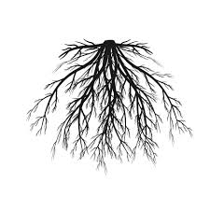
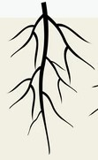

Q.8) Draw and label picture of Parts of Plant. [2M]

